**ACCESSING I/O DEVICES:**

#include <stdio.h>

#include <stdlib.h>

#include <signal.h>

// Interrupt handler function for Device 1

void device1_interrupt_handler(int signal) {

printf("Device 1 Interrupt Handler\n");

// Handle Device 1 interrupt

}

// Interrupt handler function for Device 2

void device2_interrupt_handler(int signal) {

printf("Device 2 Interrupt Handler\n");

// Handle Device 2 interrupt

}

// Enable interrupt for a device

void enable_interrupt(int device) {

switch(device) {

case 1:

signal(SIGINT, device1_interrupt_handler);

break;

case 2:

signal(SIGINT, device2_interrupt_handler);

break;

default:

printf("Invalid device\n");

break;

}

}

// Disable interrupt for a device

void disable_interrupt(int device) {

signal(SIGINT, SIG_DFL);

}

int main() {

// Enable interrupts for both devices

enable_interrupt(1);

enable_interrupt(2);

printf("Interrupts enabled for both devices. Press Ctrl+C to trigger interrupts.\n");

// Loop indefinitely to simulate device operations

while (1) {

// Perform other tasks or wait for interrupts

}

// Disable interrupts before exiting

disable_interrupt(1);

disable_interrupt(2);

return 0;

}

**OUTPUT:**

Interrupts enabled for both devices. Press Ctrl+C to trigger interrupts.

Device 2 Interrupt Handler

**BUS ARBITARY:**

#include <stdio.h>

#define NUM_DEVICES 3

// Function to simulate bus arbitration using round-robin

int busArbitrationRoundRobin(int currentDevice) {

return (currentDevice + 1) % NUM_DEVICES;

}

int main() {

int currentDevice = 0; // Start with the first device

printf("Bus Arbitration Simulation\n");

// Simulate 10 cycles of bus access

for (int cycle = 1; cycle <= 10; cycle++) {

printf("Cycle %d: Device %d accesses the bus\n", cycle, currentDevice);

// Perform some operation or task for the device accessing the bus

// ...

// Update the current device using round-robin arbitration

currentDevice = busArbitrationRoundRobin(currentDevice);

// Print a newline for better readability

printf("\n");

}

return 0;

}

**OUTPUT:**

/tmp/xEQvQsC0hU.o

Bus Arbitration Simulation

Cycle 1: Device 0 accesses the bus

Cycle 2: Device 1 accesses the bus

Cycle 3: Device 2 accesses the bus

Cycle 4: Device 0 accesses the bus

Cycle 5: Device 1 accesses the bus

Cycle 6: Device 2 accesses the bus

Cycle 7: Device 0 accesses the bus

Cycle 8: Device 1 accesses the bus

Cycle 9: Device 2 accesses the bus

Cycle 10: Device 0 accesses the bus

**Direct Memory Addressing:**

#include <stdio.h>

int main() {

int variable = 42;

int *pointer = &variable;

printf("Original value at memory location: %d\n", *pointer);

// Modify the value at the memory location directly

*pointer = 99;

printf("Modified value at memory location: %d\n", *pointer);

return 0;

}

**OUTPUT:**

/tmp/xEQvQsC0hU.o

Original value at memory location: 42

Modified value at memory location: 99

**PIPELINE INTERRUPTS:**

#include <stdio.h>

#include <signal.h>

#include <unistd.h>

// Signal handler function

void handleInterrupt(int signum) {

printf("Received interrupt signal (Ctrl+C) - exiting\n");

// You can perform cleanup or additional actions here

_exit(0); // Terminate the program immediately

}

int main() {

// Set up the signal handler

if (signal(SIGINT, handleInterrupt) == SIG_ERR) {

perror("Error setting up signal handler");

return 1;

}

// Run an infinite loop

while (1) {

printf("Program is running...\n");

sleep(1); // Simulate some work

}

return 0;

}

**OUTPUT:**

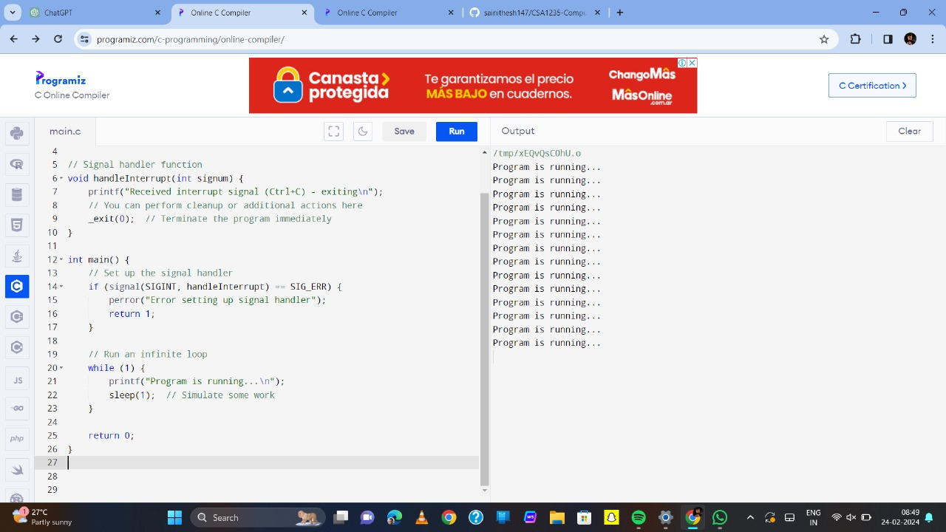

**PCI INTERRUPTS:**

#include <stdlib.h>

#include <unistd.h>

#include <signal.h>

// Define a signal handler function for the interrupt

void handle_interrupt(int signum) {

printf("PCI Interrupt Received! Signal Number: %d\n", signum);

}

int main() {

// Install the signal handler for SIGINT (you might need to use a different signal)

if (signal(SIGINT, handle_interrupt) == SIG_ERR) {

perror("Error setting up signal handler");

exit(EXIT_FAILURE);

}

// Simulate some work in the main loop

while (1) {

printf("Main Loop: Working...\n");

sleep(1);

}

return 0;

}

**Output:**

